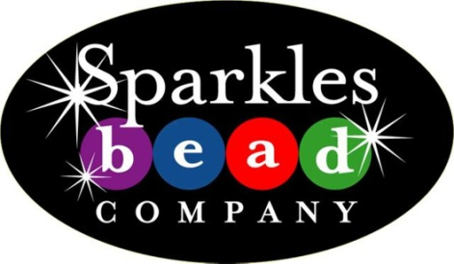
Sparkles Bead Newsletter

Hello fellow Beaders,
Some great new products have arrived at the store and we have some exciting classes coming up.
Just in:
• Pandora-style big hole beads and chain
• More Chinese Crystals
• New tools including the Wubber Looping Pliers (for perfect loops)
Classes for February and March will be as follows:
February:
Leather Wrap Bracelet - February 22nd from 6pm – 8pm

March:
Macramé Lanyard – March 1stfrom 6pm – 8pm
Taught by a guest instructor

Bling-it-up! Class – March 15th from 6pm - 8pm
Bring in an object that needs a little personality. We’ll show you how to glue on Swarovski flat back crystals and make it Sparkle! (ideas.. cell phone case, jeans, purse, shoes)

Wire Wrap class - Late March or early April (date to be determined)

We had a great time at our first Ladies Night Out. The group brought in food and beverages and had a lot of fun creating jewelry and catching up. If you're interested in a Ladies Night Out gathering, give us a call.
Come in anytime to work on your St. Patrick's Day and Easter projects!
Nancy
Sparkles Bead Co.
207 5th St. (downtown Castle Rock)
303-663-BEAD (2323) |www.sparklesbead.com

